Assignment WIMS

Assignment I –

Run the following commands in Linux shell / DOS prompt and explain with
output.

- ifconfig/ipconfig:
- Displays all current TCP/IP network configuration values and refreshes Dynamic Host Configuration Protocol (DHCP) and Domain Name System (DNS) settings. Used without parameters, ipconfig displays Internet Protocol version 4 (IPv4) and IPv6 addresses, subnet mask, and default gateway for all adapters.

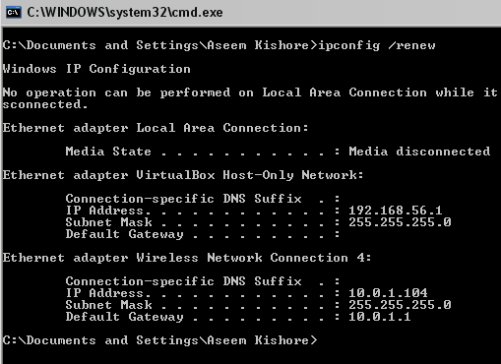

- Ping:
The ping command(used to check for network errors) to ping the IP address. Next, the request is sent over the network hub and router, in this example, to the other computer with this IP address. Once successfully received, the computer replies to the ping with a pong response. The time between these two transmissions is calculated to generate an average response or latency time.

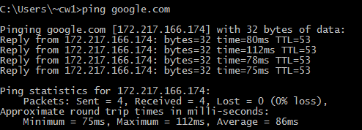

- traceroute/tracert:
The tracert command is a Command Prompt command that's used to show several details about the path that a packet takes from the computer or device you're on to whatever destination you specify.
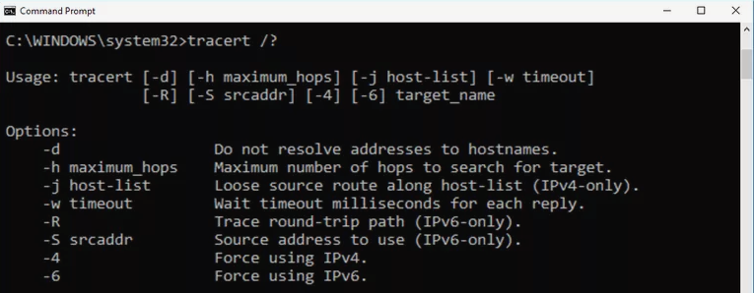
With the tracert command, we're asking tracert to show us the path from the local computer all the way to the network device with the hostname www.google.com.
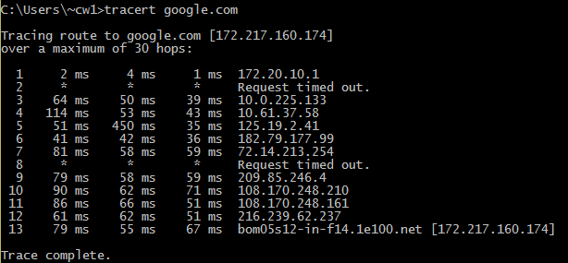
In this example, we can see that tracert identified fifteen network devices including our router at 172.20.10.1 and all the way through to the target of www.google.com, which we now know uses the public IP address of 172.217.160.174, one of Google's many IP addresses.

- netstat:
The netstat command, meaning network statistics, is a Command Prompt command used to display very detailed information about how your computer is communicating with other computers or network devices.
Specifically, the netstat command can show details about individual network connections, overall and protocol-specific networking statistics, and much more, all of which could help troubleshoot certain kinds of networking issues.

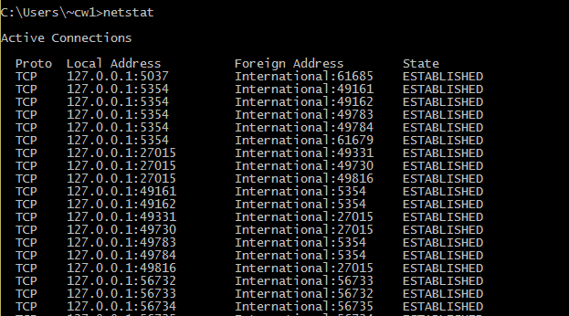
- route:
Using the route command displays or modifies the computer's routing table. For a typical computer that has a single network interface and is connected to a local area network (LAN) that has a router, the routing table is pretty simple and isn't often the source of network problems.
For a computer with more than one interface and that's configured to work as a router, the routing table is often a major source of trouble. Setting up the routing table properly is a key part of configuring a router to work.

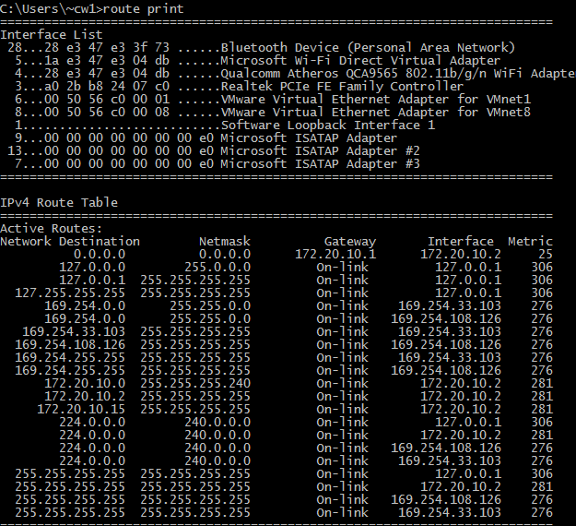

- telnet:
Telnet (short for TELetype NETwork) is a network protocol that provides a command-line interface to communicate with a device. Telnet is used most often for remote management but also sometimes for the initial setup for some devices, especially network hardware such as switches and access points. Telnet is also used to manage files on a website.

User data is interspersed in-band with telnet control information over the transmission control protocol (TCP). Often, Telnet was used on a terminal to execute functions remotely. ... The user then executes commands on the server by using specific Telnet commands into the Telnet prompt

For example, launch Command Prompt and enter “telnet International<hostname> 23<port>”. This connects to International on port 23 using Telnet.

- ftp:
FTP stands for File Transfer Protocol. FTP is a standard network protocol used to transfer files between computers (a client and server) over a TCP/IP network. It is a function of Application layer and built on client-server architecture. Client controls the conversation, while server transmits the file content.

When files are transferred through FTP, one of two actions is happening – uploading or downloading. Uploading involves transferring files from a personal computer to a server. Downloading involves transferring a file from a server to a personal computer. FTP uses TCP/IP (Transmission Control Protocol/Internet Protocol) to transfer your files. TCP/IP is basically the language that the Internet uses to carry out commands.

Assignment II

Consider sending a 3000-byte datagram into a link that has an MTU of 500 bytes. Suppose the original datagram is stamped with the identification number 422.How many fragments are generated? What are their characteristics?

Ans) Here, it is given that we have 3000 byte(includes 20 b for header and 2980 b for data.)
MTU = (20b + 480b)
Total number of fragment = {2980b/480b} = 7 packets

P7 | P6 | P5 | P4 | P3 | P2 | P1 | Comments
100+20 | 480+20 | 480+20 | 480+20 | 480+20 | 480+20 | 480+20 | Data sending
120 | 500 | 500 | 500 | 500 | 500 | 500 | Total Length
0 | 1 | 1 | 1 | 1 | 1 | 1 | More Fragment
2880/8=360 | 2400/8=300 | 1920/8=240 | 1440/8=180 | 960/8=120 | 480/8=60 | 0 | Offset

Packet 1: ID=422,TotalLength=500,MF=1,Frag_offset=0
Packet 2: ID=422,TotalLength=500,MF=1,Frag_offset=60
Packet 3: ID=422,TotalLength=500,MF=1,Frag_offset=120
Packet 4: ID=422,TotalLength=500,MF=1,Frag_offset=180
Packet 5: ID=422,TotalLength=500,MF=1,Frag_offset=240
Packet 6: ID=422,TotalLength=500,MF=1,Frag_offset=300
Packet 7: ID=422,TotalLength=120,MF=0,Frag_offset=360

Assignment III –
Network address of a class-C network is 195.172.125.0. Calculate network addresses , Host address Range and broadcast addresses for all the subnets if there are 5 subnets and 20 hosts per subnet. Also mention the default subnet mask and subnet mask after subnetting.
Ans)
Given IP : 195.172.125.0 (Default Subnet Mask : 255.255.255.0)
Given Subnets = 5 (Which covers under 2^3=8)
Given host per subnet = 20 hosts
Subnet Mask for this IP:
11111111.11111111.11111111.11100000 (Already have 2^3 so added)
255.255.255.224 (Subnet Mask for mentioned IP)
Wildcard : 00000000.00000000.00000000.00011111 (0.0.0.31)
Total Hosts per Subnet: 2^5-2=30 hosts
For First:
Network Address : 192.172.125.0/27
Broadcast Address : 192.172.125.31
For Second:
Network Address : 192.172.125.32
Broadcast Address : 192.172.125.63
For Third:
Network Address : 192.172.125.64
Broadcast Address : 192.172.125.127
For Fourth:
Network Address : 192.172.125.128
Broadcast Address : 192.172.125.159
For Fifth:
Network Address : 192.172.125.160
Broadcast Address : 192.172.125.191
For Sixth:
Network Address : 192.172.125.192
Broadcast Address : 192.172.125.223

